**Title:** Tool to analyze the health of crops and suggest remedies

**1. Problem Statement:**

Year after year, crops are plagued by a plethora of diseases. These diseases are caused by a combination of climatic conditions, lack of soil nutrients and inadequate/excessive use of pesticides to name a few. A scanty harvest, apart from affecting the farmer badly, has rippling effects in other areas as well. Either the farmer doesn’t detect the presence of diseases quick enough, or the measures he takes to rescind those effects are simply not enough. By providing the farmer with a cheap tool to detect diseases and their remedies, one can ‘weed out’ the problem right where it started.

**2. Domain:**

Agriculture, Machine learning, Artificial Intelligence, Farming, Embedded systems, Image processing.

**3. Solution:**

The aim of the project is to build a cheap, user-friendly and handy tool to help the farmer detect if his/her crops are affected by a disease. The tool will interface with other hardware devices. Using various inputs such as the time of year, quality of soil and images of crops, the tool will be able to suggest the best remedy to the farmer, if applicable. The burden on the farmer shall also be reduced too. He/she will only have to interact with a simple application. The cost of the tool shall be minimal. The device will be handy for the farmer to use instead of reaching an expert for consultation & can be powered using solar energy (renewable source - reliable, cheap & efficient).

**4. Social Impact:**

The device will help the farmers get the right pesticides to apply after precise diagnosis of the disease. Usually, a farmer has to go to a government office to get consultation for their crop related problems/detection of nutrient levels. Sometimes, a farmer might not be able to detect the right disease. So, the farmer is forced to buy a wide target pesticide/fertilizer that affects the non-target organisms and also the consumers. So diagnosis and suggestion of specific pesticides saves money and the plant’s health will be in control.

**5. How do you want to implement the project?**

Components required: Microcontroller with computational ability, Camera, NPK sensor, pH level sensor, Temperature & humidity sensor, Mobile phone.

The proposed solution consists of a handy embedded device and an app integrated together. The embedded device will include a Microcontroller, a camera, a NPK level sensor, pH sensor, soil moisture, temperature, salinity sensors as well as atmospheric temperature and humidity sensors.

The camera will be used to collect images of the diseased crops. These images will be processed using a developed AI model to detect the visible symptoms of the disease/deficiency.

An AI model is developed and trained using pre-existing data for suggesting the pesticide levels for that particular crop disease. The AI model predicts the disease which is affecting the plants. It also suggests the amount and type of pesticide that needs to be applied to the affected crops.

Further it also recommends the frequency of application for that specific crop. So the model will be trained for some specific crops and hence the suggestions of the pesticide and NPK levels will be crop specific.

An app is developed which will act as an interface between the embedded device and the farmer.

The NPK level sensor collects the data on the nutrient levels present in the soil. Using this data the AI model predicts the nutrients that are deficient in the soil and thus, predicts the amount of nutrients that are required in the soil for healthy/optimum growth of the crops. This recommendation can be used by the farmers to buy the required amount of fertilizers and macronutrients accordingly.

The pH level sensor is used to find the pH of the soil. If the pH goes beyond an acceptable limit then the device alerts the user through the developed app. The temperature and humidity sensor collects the atmospheric and soil temperature, atmospheric humidity/soil moisture. Using the data collected from these sensors, the suggestions will be made by the app (like the nutrient levels needed for that particular weather - using temperature and humidity levels,also suggests the right amount of pesticides to use so that it doesn’t affect the optimal pH level of the soil & based on the temperature and weather conditions, predict the pests that will attack the plant/crop and recommend the right amount of pesticide required for the crop).

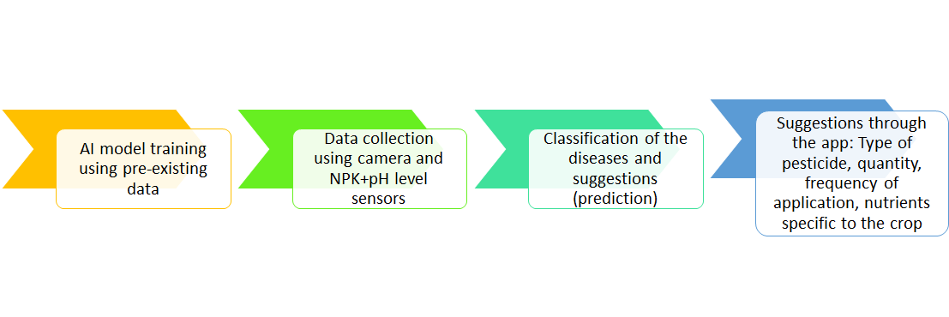

Flowchart explaining the implementation of the project

**6. Hardware Architecture (High level Block diagram)**

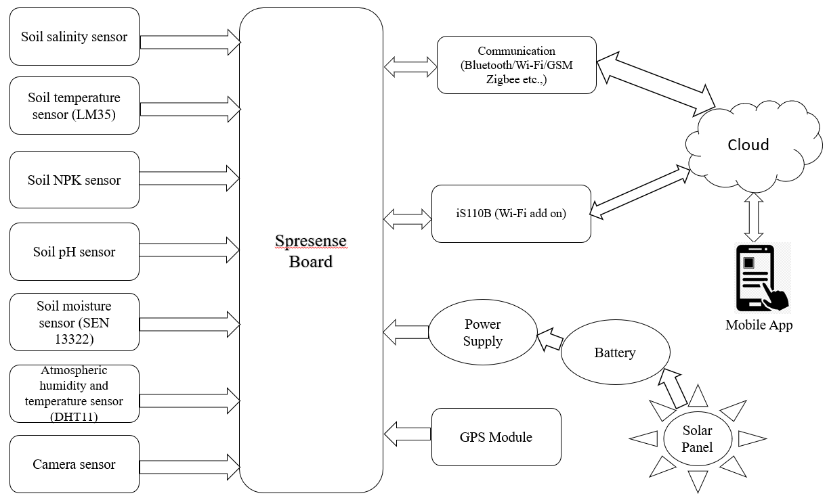

**7. Software Architecture (High level Block diagram)**

